Lab 3 – Biodiversity
Experiment 1: Effects of Water Pollution on Plant Diversity
Water pollution can have severely negative effects on biodiversity and ecosystems, particularly on plant populations. In many cases, these pollutants are introduced to the environment through everyday human activity. In this experiment, you will contaminate several water samples, as well as purify a water sample. You will then evaluate the effects of water pollution and purification on the biodiversity of wildflowers.

POST-LAB QUESTIONS

Table 1: Water Observations (smell, color, etc.)
Beaker | Observations
1
2
3
4
5
6
7
8

1. What effects did each of the contaminants have on the water in the experiment? Use Table 1 for reference.
Answer =

2. What kinds of human activities could cause oil, acids, and detergents to contaminate the water supply?
Answer =

3. What are the differences in color, smell, visibility, etc. between the “contaminated” water and the “treated” water?
Answer =

4. From the introduction to Lab 2, you know that there are typically five steps involved in the water treatment process. Identify the processes (e.g., coagulation) that were used in this lab and describe how they were performed.
Answer =

5. Develop a hypothesis regarding how using contaminated or purified water might affect plant biodiversity. Which pot do you believe will contain the greatest biodiversity (greatest number of species)? Why?
Hypothesis =

Table 2: Number of Plant Species Present in the Pots
Species Observed | Tap Water | Contaminated Water | Purified Water
Zinnia | Y N | Y N | Y N
Marigold | Y N | Y N | Y N
Morning Glory | Y N | Y N | Y N
Cosmos | Y N | Y N | Y N
Ryegrass | Y N | Y N | Y N
Total Number of Species in Pot:

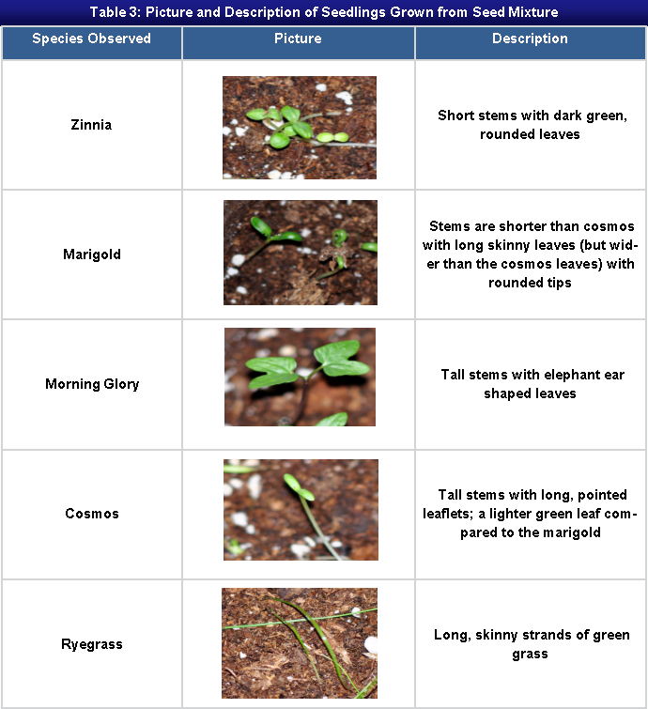

- Based on the results of your experiment, would you reject or accept the hypothesis that you produced in question 5? Explain how you determined this.

Accept/Reject =

- Alum contains aluminum. Research the effects of aluminum on plants by finding a scholarly source online. Does your research provide any insight into your results? Discuss your findings as they relate to the results of your experiment.

Answer =

- Imagine that each pot was a sample you found in a group of wildflowers. Based on the diversity of flowers in each pot, would you consider the ecosystem to be healthy? Why or why not?

Answer =

- How does biodiversity contribute to the overall health of an ecosystem? Provide specific examples and utilize at least one scholarly resource to back your answer.

Answer =

- Rank the following three scenarios in terms of having the most to least biodiversity and provide your rationale for these rankings.
- A vacant lot behind a car repair facility.
- A designated national wilderness area.
- A grassy strip along the highway.

Answer =

References
Any sources utilized should be listed here.

